MODULE 2
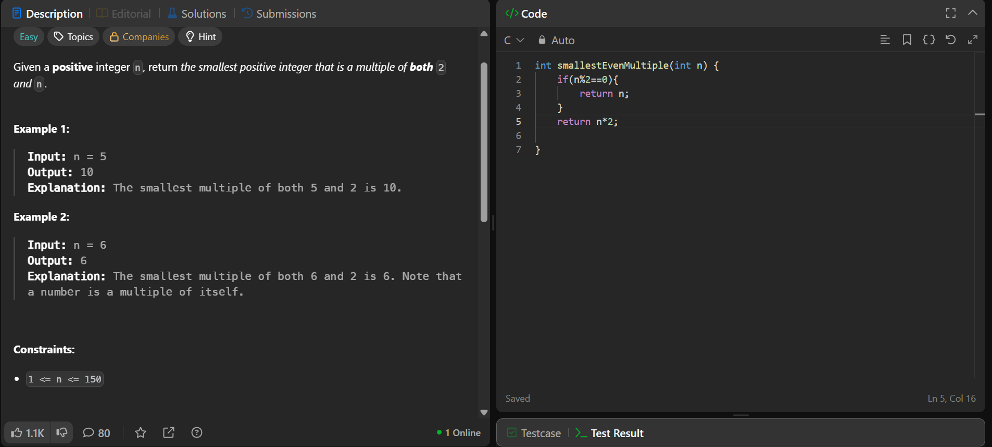
Q7 https://leetcode.com/problems/smallest-even-multiple/



